**CODE**

TITLE My First Program (Test.asm)

INCLUDE Irvine32.inc

.data

;task1

val1 SBYTE ?

val2 SBYTE -10h

;task2

idata WORD ?

;task3

val3 SDWORD 12,147,483,648h

;task4

wArray BYTE 1h,2h,3h

;task5

myCol BYTE "Black",0

;task6

A DWORD 12

B DWORD 2

val DWORD 1

D DWORD 8

E DWORD 14

value DWORD ?

.code

main PROC

;task1

mov al,val2

mov val1,al

mov ah,val1

;task2

mov idata,bx

mov cx,idata

;task3

mov edx,val3

;task 4

mov eax,ASS

mul B

mov ecx,val

add eax,ecx

mul D

sub eax,E

mov value,eax

mov ebx,value

call DumpRegs

exit

main ENDP

END main

**SNIPPETS**

**Q1-Q5**

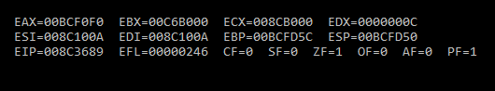

**Q6**

